# Wireframe Document

## Overview

The wireframe for the Credit Card Fraud Detection project outlines the design and layout of the user interface (UI). The wireframe ensures that the UI is intuitive, user-friendly, and aligned with the project’s objectives. This document provides a detailed description of the interface components and their functionality.

## Key Components

1. **Header**: The header includes the title of the application, providing a clear indication of the application’s purpose.
2. **Input Form**: A form where users input the feature values required for the prediction.
3. **Prediction Result Area**: Displays the prediction result after the user submits the form.

## Layout Description

### Header

* **Position**: Top center
* **Content**: Application title "Credit Card Fraud Detection"
* **Style**:
  + Font: Bold, large font size
  + Color: Dark
  + Alignment: Centered

### Input Form

* **Position**: Centered below the header
* **Content**: A text area for entering the 23 feature values
* **Labels and Instructions**: Clear label for the input field and placeholder text within the text area
* **Button**: A "Predict" button to submit the form
* **Style**:
  + Text area: Standard font size, sufficient padding
  + Button: Prominent color (e.g., blue), centered, large size for easy clicking
  + Instructions: Smaller font, light color to avoid distraction but clear enough to read

### Prediction Result Area

* **Position**: Below the input form
* **Content**: Displays the prediction result in an alert box
* **Style**:
  + Alert box: Informational style (e.g., light blue background)
  + Font: Bold for the result, standard size for additional text
  + Alignment: Centered within the container

**Home Page:**

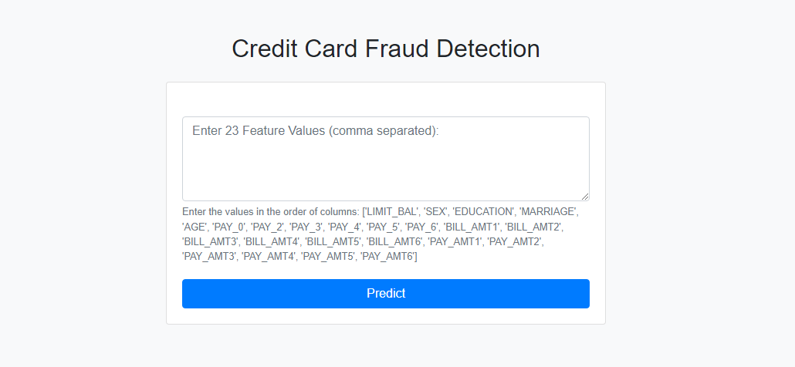

**Prediction:**

